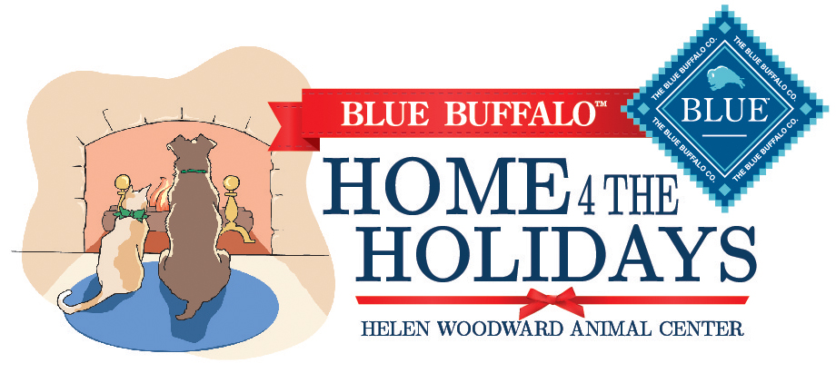

Helen Woodward Animal Center is proud to partner with Blue Buffalo as the official Blue Buffalo Home 4 the Holidays supporter. Blue Buffalo is again offering two pet food prizes to organizations participating in 2016’s Home 4 the Holidays adoption campaign. **Two selected Home 4 the Holidays partners will win 1,250 pounds of dry dog or cat food for their organization!**

**How Can You Qualify For The Prize?**

The winners will be selected out of a pool of the top participating organizations in this year’s campaign. To qualify, organizations must report ***every week*** on the number of pet adoptions done that period.

You will also get one bonus entry for every time you show us how a How-To Guide tip or principle helped market your adoptable pets:

* + A media story or article which was in your local news,
  + An adoption event or promotion in the news,
  + A proclamation that was signed to help orphan pets.

To send us media articles, videos or listing, email **h4th@animalcenter.org** or tweet us at [**@hwac**](https://twitter.com/HWAC).

**So, remember, to qualify for Blue Buffalo’s pet food prize you must do your weekly adoption reporting.** Report all adoptions, every week, at [www.home4theholidays.org](http://www.home4theholidays.org).

Winners will be notified via the email listed in their organization’s Home 4 the Holidays account in February, 2017.